**Bucket Versioning:**

* When we enable the bucket versioning which will keeps the multiple versions of the objects.(If we do the modification on same object and upload it again in same bucket bucket versioning helps to store the two objects one is previous and another one is updated object)
* We can retrieve and restore the data if someone deleted the object.

**Steps to enable the Bucket Versioning:**

* Open the bucket and click on properties.
* Click on edit in bucket versioning section.
* Select enable option and click on save changes.
* Or We can enable the bucket versioning while creating the bucket.

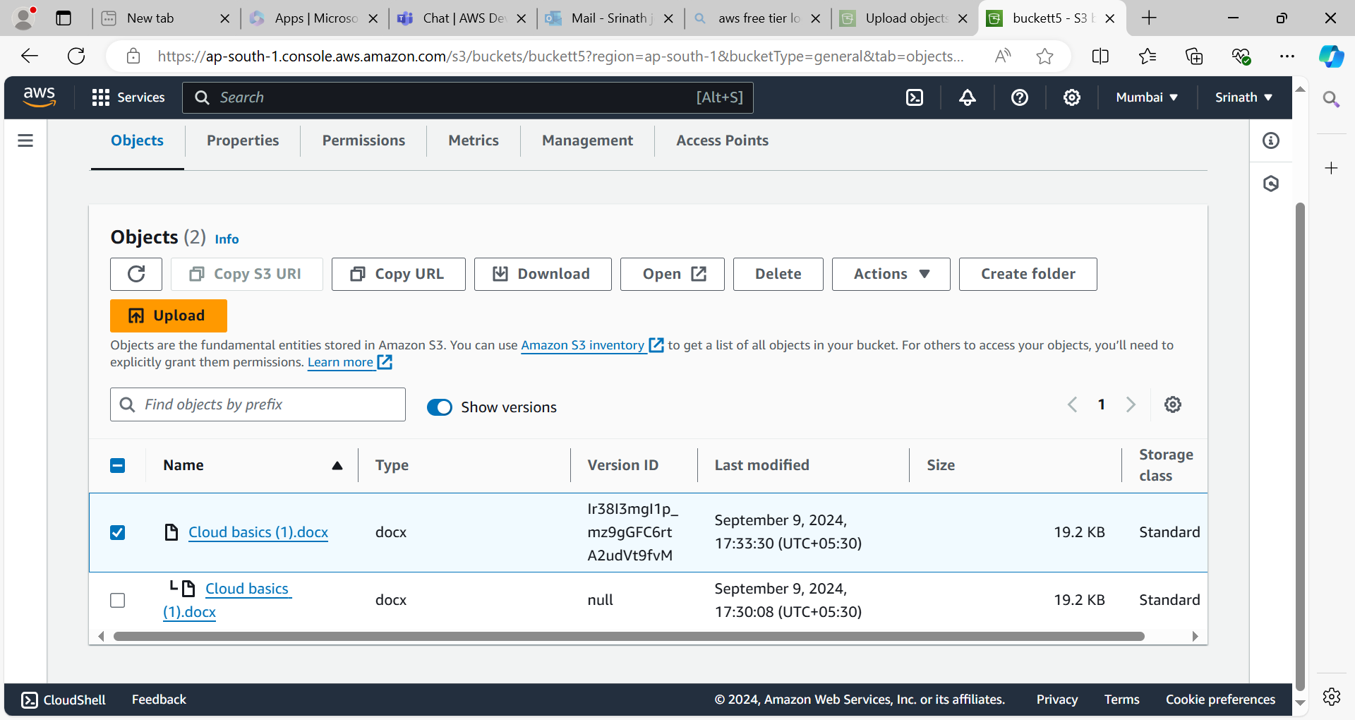

**Types of Storage Classes:**

**Standard Frequent :**

* In which class data will be accessed frequently.
* The data will be stored more than 3 availability zones.
* Cost is high compared to other storage classes.
* Data will be high available .

**Standard Infrequent:**

* Access the data infrequently in this class like upto 30 days.
* Data will be stored more than 3 availability zones.
* Cost is less compared to standard frequent.

**One zone Infrequent:**

* Access the data infrequently but data will be stored in one availability zone.
* Cost is less but data will be lost if availability zone is destroyed.
* Cost is less compared to standard infrequent storage class.

**Glacier:**

* In which class data will be compressed and stored it in more than 3 availability zones.
* Cost is less compared to standard frequent and infrequent classes.
* If we want to access the data upto 90 days at that time we can use this storage class.
* Retrieval time or restore the data within a minutes or seconds.

**Glacier Deep Archive:**

* The data will be very compressed than glacier and store it in more than 3 availability zones.
* Cost is very less compared to other storage classes.
* Data will be stored upto 180 days.
* Retrieval time is minimum 12 hours.

**Intelligent Tiering:**

* We don’t know whether the data will be frequently accessed or not at that time we can select this storage class.
* Data will be stored in more than 3 availability zones.

**Reduced Redundancy:**

* Data will be frequently accessed and stored it in more than 3 availability zones.
* But data will be lost in this storage class so it is not recommended storage class.